CS331 : Software engineering lab

**DySAS Software Testing Report**

horizontal line

# Introduction

Our project provides a modern makeover of the age-old manual examination system with the aim of reducing effort for teachers in choosing questions and checking results and increasing the ease of giving exams for students. This project allows students to give exams anywhere they want, provides a questionnaire for teachers to choose questions from and easy creation of tests for teachers. The project utilizes several APIs and in this report we will perform testing on those APIs.

# Testing

The following tests are to be performed :

* Unit testing
* Integration testing
* System testing

### Unit testing

Unit testing is a type of software testing where individual units or components of a software are tested. The purpose is to validate that each unit of the software code performs as expected. A unit may be an individual function, method, procedure, module, or object.

For the purposes of unit testing, we have used mocha, a popular node.js testing library, along with chai for assertion purposes. The testing code for our modules looks like this :

#### Example testing code

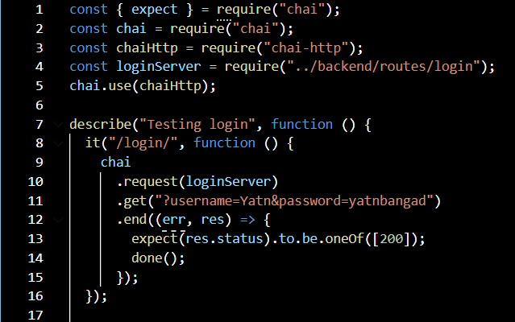

The results of our unit testing are:

#### Signup module

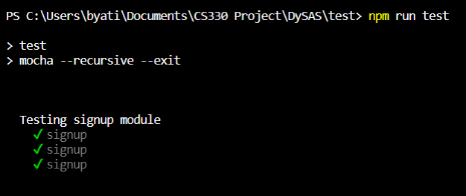

#### Sigin module

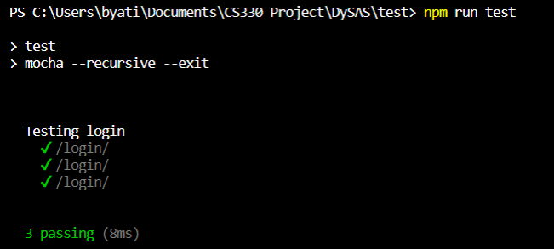

#### Dashboard module

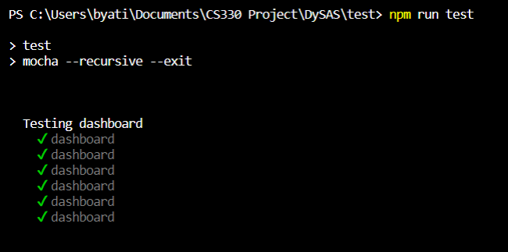

#### Coursepage module

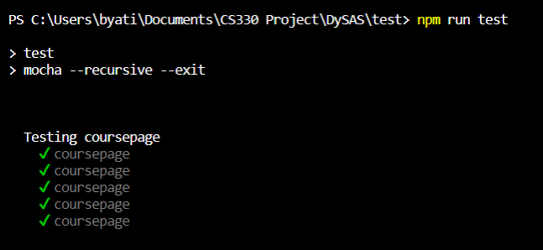

#### Exam module

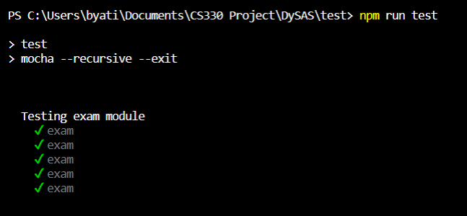

#### Result module

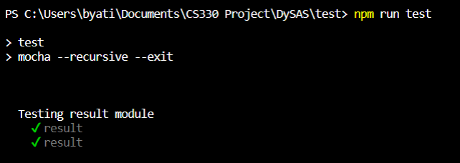

### Integration testing

Integration testing is defined as a type of testing where software modules are integrated logically and tested as a group. The purpose of this level of testing is to expose defects in the interaction between these software modules when they are integrated.

After running all unit tests, we discovered that our modules are loosely coupled and do not require separate integration testing. We performed manual integration testing and ensured that our units are working with each other as expected.

### System testing

System testing is a level of testing that validates the complete and fully integrated software product. The purpose of a system test is to evaluate the end-to-end system specifications. We performed system testing on our fully integrated system to evaluate our system’s responses to various testcases and check their compliance with the requirements.

1. **Signup**

| Testcase | Result |
| --- | --- |
| User registration with valid email id | Successful user registration |
| User registration with invalid email id | Invalid email id error |
| User registration with already registered email id | Account with same email id exists error |

1. **Sign In**

| Testcase | Result |
| --- | --- |
| Login with wrong email id and password | Invalid credentials error displayed |
| Login with correct email id and wrong password | Invalid password error displayed |
| Login with correct email id and password | Successful user login |

1. **Dashboard**

| Testcase | Result |
| --- | --- |
| Access dashboard page without login | Redirected to login page |
| Access dashboard page with login | Dashboard page loads |
| Access create new classroom without admin role | Only administrators can create classrooms error displayed |
| Access create new classroom with admin role | Redirected to create classroom page |
| Create new classroom with invalid entries | Error message stating which entries are invalid |
| Create new classroom with all valid entries | New classroom created |

1. **Coursepage**

| Testcase | Result |
| --- | --- |
| Access coursepage without login | Redirected to login page |
| Access coursepage with login | Coursepage loads |
| Create new test without admin role | Only administrators can create new tests |
| Create new test with admin role | New test page opens |
| Create new test with invalid or missing entries | Error message showing the invalid fields |

1. **Exam page**

| Testcase | Result |
| --- | --- |
| Attempting test without login | Redirected to login page |
| Attempting test with login | Test page opens |
| Clicking finish test before reaching the last question | You can only end the test on the last question error displayed |
| Clicking clear choice with no choice selected | No error message is displayed |
| Clicking next question | Next question page loads |

1. **Results page**

| Testcase | Result |
| --- | --- |
| Clicking the challenge button | Opens the challenge question popup |
| Fill all fields and submit | Redirects back to result page |

After concluding the above testing, we ironed out all irregularities in our units and in their integration. We have now ensured that our entire system works smoothly and faultlessly under all circumstances.